Title or Task: |   

Description:

Files Required
Suitable for Classes: | AIT • Multimedia • Cert II IT • Cert II Bus
Area: | Technology & Enterprise
Teacher: | Mr Peter Faulks

Timeline

Date Due:
Task Brief: | In class lesson

Outcomes:

Items highlighted in yellow are tasks for you to complete
Items in Blue italics are help tips

These pages are designed to show you how to use software packages; various software updates may have taken place so some pages will not apply to versions other than those listed here. In some cases data files may be required.

Use an advertisement from below; find a professional position being offered. You may bring an advert from the local newspaper if you wish.

Write a letter applying for the position providing personal details and your opinion as to why you would be suitable for the position offered.

Position 1



Position 2



Position 3

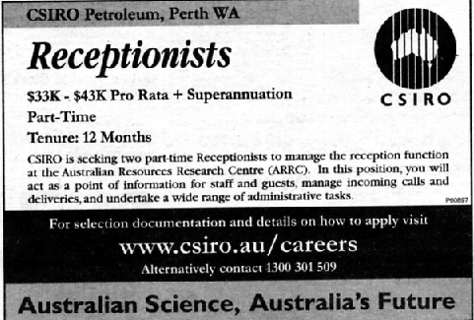

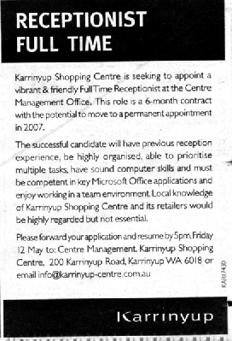
Position 4

Position 5

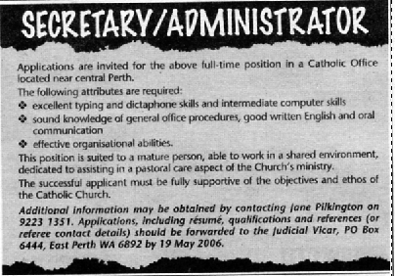
Save the work



